**Module Name: Web Authoring**

**Module Code: 5N1910**

**Assignment Name: Project Phase I**

**Weighting: 20%**

**Your Name: Steven Joyce**

**Class Group: Computer Science**

**Tutor Name: Darren Stones**

**Issue Date: 3 October 2016**

**Due Date: 14th November 2016**

**Web Authoring Project**

**Website topic:** *Irish Sporting Legends*

**Target Market**

The target audience for this website is sports fans. The website has a mainly national audience and can be read by anyone no matter what age they are. Anyone you has an interest in Sporting history of a country, will be targeted as the websites audience.

**Site Objectives**

With this website, I want to educate people on the rich and proud sporting history the Republic of Ireland has despite our small population. I also want to pay homage to the forgotten legends of Irish sport. People who have been forgotten as their generation got older or have passed away.

**Site map diagram**



**Logical navigation solution(s)**

The navigation solutions I use will be tabs at the top of each page to go onto the next page. On the front page, I have buttons linking you to each page of the website by their sports. Also on the bottom of each page I will have a Back to Top button to make the page go up to the top so the reader can click on a new sport at the top of the page.







**Sketches of initial design concepts**

I used the website: <http://sneakpeekit.com/> to sketch my website design on the website itself. I then screenshotted the finished sketch and uploaded it to this document.

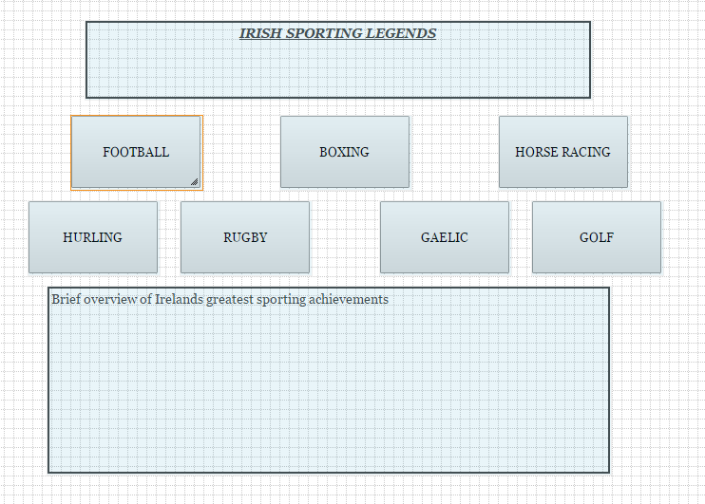

This is my template for every other page of my website.

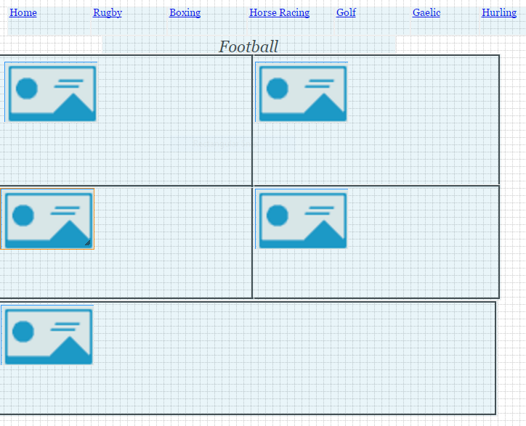

**Tools for creation and maintenance of website**

To create the website, I will use a web host such as 000webhost to publish my website. I will use Photoshop to help re-size my images and put them in the style I want to use. I will also use FileZilla to upload my files to my webhost.

**Design a user interface for specified target audience**

**Contrast:** I will have a white background because it makes the black writing stand out. It also enhances the ability of the picture to stand out and draw the reader into the text.

**Repetition:** I have begun to understand that to make the reader view the website with ease you need to make the website have a reoccurring layout. I will have all my pages designed with the same format design.

**Alignment:** The structure of a website need to have symmetry to make the viewer see all the info properly and without any issues. Therefore, I chose to have all the text and images are in line with one another. All tabs will be in line with one another and be on the same line.

**Proximity:** The importance of proximity cannot be understated because the way everything is layout will either hinder of ease the ability of a reader to view the website. Therefore, I chose to have all writing in line with one another.